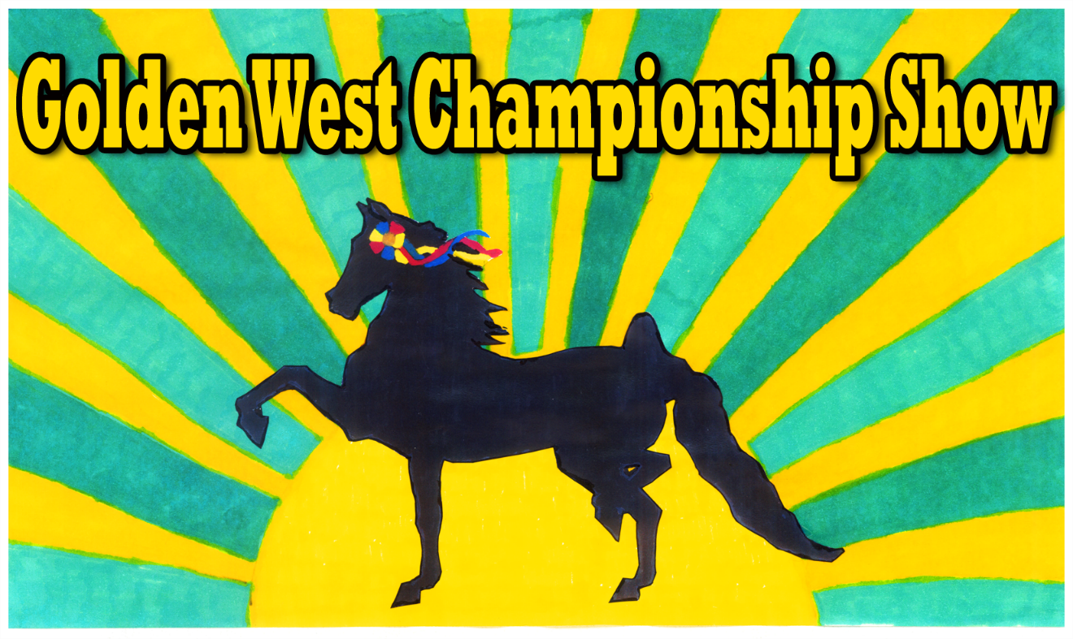
GOLDEN WEST CHAMPIONSHIP
MODEL HORSE SHOW

OCTOBER 6, 7, 8, 2017

GEORGE INGLES EQUESTRIAN CENTER
3737 CRESTVIEW DRIVE
NORCO, CALIFORNIA 92860

CO-SHOW HOSTS: SUZIE FRANCIS
SHARON MASSOURIS

For information:
SUZIE: seahorsecastles@yahoo.comSharon:smhomefree@att.net

2017 CHAMP SHOW QUALIFIERS

2016
2/6 ROAD APPLE DRIVE SUSAN GAGE
3/5 RED ROCK PLASTIC PONIES SHELLY HOGEL
4/9 FANTASTIC PLASTIC JANE MOREHOUSE
4/10 BAY AREA ALL HALTER ROBIN KENT
4/23 SO CAL LIVE JULIE DEWYER
5/21 FIRST SHOW OF THE NEW SHARON MASSOURIS
SEASON
6/11 GOLD COUNTRY ROBIN KENT
6/18 MODELS IN THE MOUNTAINS CORINA ROBERTS
10/7 SLEEPY HOLLOW SUZANNE FRANCIS
10/8 ONE WOMEN SHOW (OF)-AZ TERESA CANDELARIA
10/15 ONE WOMEN SHOW (CUST) TERESA CANDELARIA
10/22 ZION MODEL SHOW UT ALISON URAL-CAWLEY
12/10 WACCO JANE MOREHOUSE
12/11 WINTER FESTIVUS KRISTEN ARDENT

2017
3-4 RED ROCK PLASTIC PONIES SHELLY HOGEL
3/24 KICK AZ LIVE/MINIS MAX-AZ TERESA CANDELARIA
4/1 FANTASIC PLASTIC JANE MOREHOUSE
4/2 BAY AREA ALL HALTER ROBIN KENT
4 /2 SPRING SHOW AMONG TERI WALSH
FRIENDS
4/22 SO CAL LIVE JULIE DEWYER
4/30 TUSCON MODEL SHOW MARILYN JENSEN
5/13 PIONEER CLASSIC UT TARA OLIVER
5/20 FIRST SHOW OF THE NEW SHARON MASSOURIS
6/3 ACHEY ACRES HEATHER VISSER
6/4 BIG VALLEY PERFORMANCE HEATHER VISSER
6/10 GOLDEN WEST JAMBOREE SUZANNE FRANCIS
6/16 MODELS IN THE MOUNTAINS CORINA ROBERTS

